FIP Briefs

# [1050]

# [1051] Final Integrated Project

# Requirements

## Illustrator Logo:

#### Must include:

3 Colours

Logo must consist of a ”designed“ symbol and text.

MAXIMUM two (2) Fonts used for text.

## Website Photoshop File Setup:

#### Photoshop files and content need:

• Proper naming convention

• All layers named

• Appropriate use of Groups/Folders

• Appropriate use of Adjustment Layers, Vector Smart Objects,

Smart Objects etc.

• Non-destructive editing techniques

## Submission

Create a folder named 'mmed-1051' in the 'assets' folder of your

internet site folder structure (Web class) and place your Illustrator

Logo and Website Photoshop files in it.

Zip up your entire internet site folder and upload it to FOL

Submission dropbox called ‘Final Integrated Assignment - Website

Project = 30%’

[1052] Project3: Final Integrated Assignment

STUDENT WEBSITE 03_FINAL PROJECT

Semantic Tagging & CSS layout

Assignment Description: Each student is required to create a three (3) page website based on the HMTL/ CSS templates provided in class. The subject of the website is entirely up to the student. The design must be an HTML5 fixed-width site utilizing flexbox as the primary method of layout. Students must adhere to the layout set by the template photoshop file.

Assignment Requirements:

Web Pages -3 pages (1 contact page) -Semantic HTML 5 tagging -Valid HTML5 -Proper Document Outline -Link to CSS files -Valid CSS -CSS flexbox based layout -Properly compressed and scaled images images

Additional Components -All photographs or images must be taken by you, created by you, or pulled from a stock photo website.  
Additional information will be given in class, you are encouraged and expected to ask questions, if you are absent it is your responsibility to check with other students.

Submission: - Projects must be submitted at the end of Week 13 (More info will be provided). Submission requirements are as follows: - Link to Github repo: master branch with dev branches as required (don’t delete branches). - ONLY THE MASTER BRANCH WILL BE GRADED!!! - secondary branches should be named appropriately IE dev.tvr.bio, dev.jb.bio - Submit the repo link and partner names via FOL dropbox - DO NOT submit files. They will be ignored.

Project Repo Contents: - index.html, ?.html and contact.html - images folder - css folder - js folder - assets folder (everything you used in the creation of this project - psd, ai, etc,) - includes folder  
PLEASE NOTE: That your project will not be graded unless you adhere to what has been outlined for you in this document. Individual practices that were given to you during the semester are applicable here as well. i.e., A photoshop file with improperly labeled layers, code not in between body tags, lack of naming conventions, etc.

Naming convention for submission: LastName_FirstName_Integrated

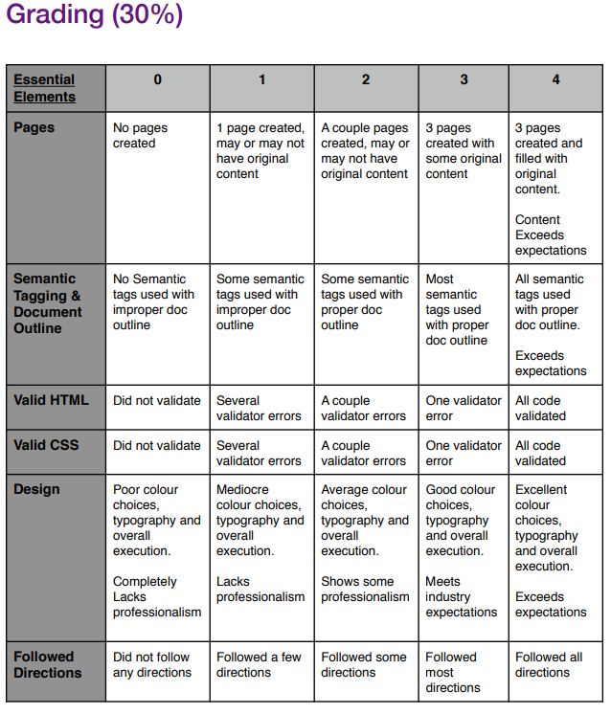

[1053]

[1054] Final Integrated Project

Posted Nov 9, 2019 2:33 PM

Hi all

For the fall term, I'm only grading workflow (Github) stuff for your final integrated project. The document you went through with Justin at the beginning of the semester includes submission requirements - Git, Github, branches, a link to the repo etc. Make sure you're not forgetting to do that stuff - don't just submit a zipped project.

A well-written Readme doc is expected as well.

Thanks

TVR

* Workflow, Commits and organized branches
* Great Readme doc

1050 -

1051 – Dec 8, 11:30 pm

1052 – Dec 8, 11:59 pm

1053 – Dec 8, 11:30 pm

1054 -